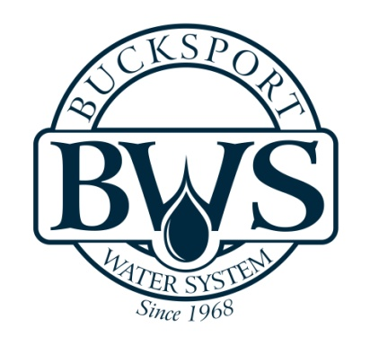
Water Users Agreement

This agreement, between BUCKSPORT WATER SYSTEM, INC., a non-profit corporation, organized and existing under and by virtue of the laws of the State of South Carolina, hereinafter called the Corporation, and ___________________________member, hereinafter called the Member. (First & Last Name)

WHEREAS, the Member desires to purchase water for domestic, business, or other uses from the Corporation, and to enter into a Water Users Agreement as required by the Bylaws of the Corporation.

NOW, THEREFORE, in consideration of the mutual covenants, promises, and agreements herein contained, it is hereby understood and agreed:

The Corporation shall furnish, subject to the limitation hereinafter provided for, such quantity of water at the member’s property located at:

_____________________________________________________________________________. (Address)

The Member shall install and maintain at his/her own expense a service line, beginning at his property line and extending to his dwelling or facility to be served.

The Member’s service line shall connect with the distribution system of the Corporation at the nearest place of desired use by the Member, provided that the Corporation has determined in advance that the water system is of sufficient capacity to permit delivery of water at that point.

The Member shall pay for water at such rates, times, and place as shall be determined by the Board of Directors of the Corporation. Only one (1) dwelling or facility shall be served through one (1) meter.

The Member agrees that he/she will make no physical connection between any private water system and the water system of the Corporation. The Corporation may make inspections to enforce these provisions. Violation shall be grounds for disconnection of the service.

The Corporation shall purchase and install a cutoff valve and may also include a water meter in each service. Such a cutoff valve and meter shall be installed within three (3) feet of the distribution right-of-way. The Corporation shall have exclusive right to use such cutoff valve and water meter and to turn it on and off. The Member shall keep the meter and box in good repair and easily accessible to the Corporation. The member agrees that he/she will not have concrete on top of or around the water meter and box. The Corporation may refuse service to any Member who tampers with a meter or other measuring device.

The Corporation shall have final jurisdiction in any question of location of any service line connection to it distribution system; shall determine the allocation of water to Members in the event of a water shortage; may shut off the water to a Member who allows a connection or extension to be made to his/her service line for the purpose of supplying water to another user.

Bills are due when rendered. The failure of a Member to pay water charges duly imposed shall result in the following penalties:
- Nonpayment by the 25th of the month will be subject to a penalty of five ($5.00) Dollars or 10%, whichever is greater.
- Nonpayment by the 10th of the following month will be subject to disconnection.
- Nonpayment for sixty days after original due date will allow the Corporation, in addition to all other rights and remedies to terminate membership, and in such event the Member shall not be entitled to receive, nor the Corporation obligated to supply any water under this agreement.

Membership may be canceled and/or services discontinued by the Corporation for any violation of any rule, regulation, or condition of service and especially for any of the following reasons:
- Misrepresentation in application as to the property or facilities to be supplied or use to be made of the service.
- Tampering with main lines, meters or valves or permitting such tampering by others.
- Connections, or cross-connections, from the Member’s service line to facilities not covered by this agreement.

IN WITNESS WHEREOF, we have hereunto executed this agreement on _____________.
(Date)

____________________________________

Member Signature

